**SENTIMENT ANALYSIS FOR MARKETING**

# TEAM MEMBERS

963521104020 – Infant jeno.j

963521104040 – mohamed althaf.a

963521104041 – mohamMed ameen.m

963521104042 – nathim khan.p

963521104304 – VIVEK.A

Project Title: Sentiment Analysis

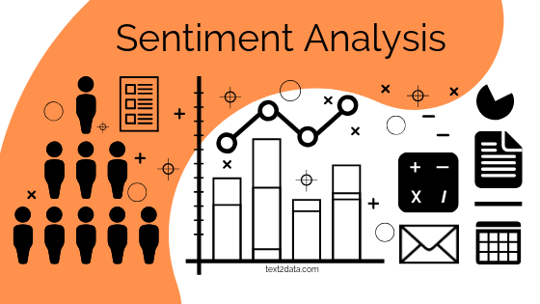

Problem Statement: This type of project can show you what it’s like to work as an NLP specialist. For this project, you want to find out how customers evaluate competitor products, i.e., what they like and dislike. It’s a great business case. Learning what customers like about competing products can be a great way to improve your own product, so this is something that many companies are actively trying to do. Employ different NLP methods to get a deeper understanding of customer feedback and opinion.

**SENTIMENT ANALYSIS FOR MARKETING**

# **Abstract:**

Sentiment analysis has emerged as a crucial tool in the field of marketing, enabling businesses to gain valuable insights into customer opinions and emotions expressed in text data. In this paper, we propose a modular framework for sentiment analysis tailored specifically for marketing applications. Our approach consists of four distinct modules, each designed to address different aspects of sentiment analysis, offering marketers a comprehensive toolkit for better understanding customer sentiment and enhancing their marketing strategies.

# **Modules:**

## 1: Data Collection and Preprocessing

The first module focuses on collecting and preprocessing data from various sources, including social media, customer reviews, and surveys. It involves techniques for data scraping, text cleaning, and noise reduction to ensure the quality and reliability of the input data.

## 2: Sentiment Classification

In the second module, we implement sentiment classification models that categorize text data into sentiment classes such as positive, negative, or neutral. We explore both traditional machine learning algorithms and deep learning techniques, providing marketers with options to choose models that best suit their specific data and requirements.

## 3: Aspect-Based Sentiment Analysis

Understanding sentiment at a granular level is essential for marketers. Module 3 introduces aspect-based sentiment analysis, which identifies and evaluates sentiment towards specific product features or attributes. This module enables marketers to pinpoint areas for improvement and tailor their marketing strategies accordingly.

## 4: Sentiment Visualization and Reporting

The final module focuses on visualizing sentiment analysis results in an accessible and actionable manner. We provide tools for generating sentiment reports, dashboards, and interactive visualizations to aid marketers in making informed decisions and tracking the impact of their strategies over time.

By adopting this modular approach to sentiment analysis, marketers can streamline their sentiment analysis workflows, gain deeper insights into customer sentiment, and adapt their marketing strategies effectively. Furthermore, the flexibility of the framework allows for customization based on specific industry domains and marketing goals, making it a valuable asset for businesses aiming to stay competitive in the ever-evolving landscape of marketing.